CO1-Lab Experiments

Name: K Sasi Rekha
Reg No: 192424010

Question 1: Student Performance Prediction
A college develops a neural network to predict student examination scores using attendance and internal assessment marks. The model trained using Gradient Descent shows a slow decrease in loss, while the model trained using SGD shows fluctuations in loss across epochs. Analyze the training behavior of both optimizers by implementing the models using TensorFlow and Keras, storing loss values using NumPy, and plotting the loss curves using Matplotlib. Identify the possible reasons for the differences in convergence.
Packages: NumPy, TensorFlow, Keras, Matplotlib
Aim: To compare Gradient Descent and SGD using training loss curves.

Program
import numpy as np
import tensorflow as tf
import matplotlib.pyplot as plt
X = np.array([[60, 50], [70, 60], [80, 70],
[90, 85], [65, 55]], dtype=float) / 100
y = np.array([50, 60, 70, 85, 55], dtype=float) / 100
# Gradient Descent
m1 = tf.keras.Sequential([
tf.keras.layers.Input(shape=(2,)),
tf.keras.layers.Dense(1)
])
m1.compile(optimizer=tf.keras.optimizers.SGD(0.01), loss='mse')
h1 = m1.fit(X, y, epochs=30, batch_size=5, verbose=0)
# SGD
m2 = tf.keras.Sequential([
tf.keras.layers.Input(shape=(2,)),
tf.keras.layers.Dense(1)
])
m2.compile(optimizer=tf.keras.optimizers.SGD(0.01), loss='mse')
h2 = m2.fit(X, y, epochs=30, batch_size=1, verbose=0)
loss1 = np.array(h1.history['loss'])
loss2 = np.array(h2.history['loss'])
plt.plot(loss1, label='Gradient Descent')
plt.plot(loss2, label='SGD')
plt.xlabel('Epochs')
plt.ylabel('Loss')
plt.legend()
plt.show()

Output:
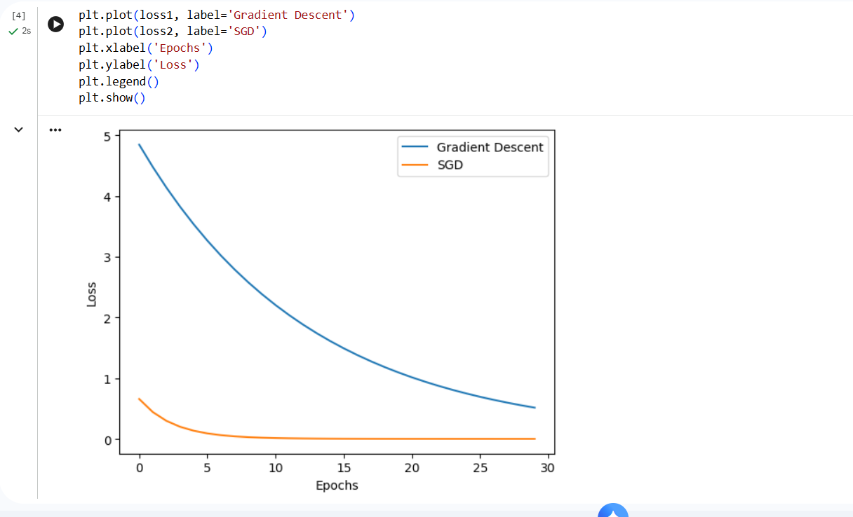

Result
Result: Gradient Descent generally produces smoother updates, while SGD may fluctuate because it uses one sample per update.

Question 2: House Price Prediction
A real-estate company trains a neural network to predict house prices. During training, the loss decreases rapidly at first but fluctuates significantly when SGD is used with a high learning rate. When a smaller learning rate is used, training becomes more stable but slower. Analyze how the learning rate affects SGD convergence by training the model with different learning rates using TensorFlow and Keras. Use NumPy to organize the loss values and Matplotlib to compare the loss curves. Determine which learning-rate setting provides a better balance between convergence speed and stability.
Packages: NumPy, TensorFlow, Keras, Matplotlib
Aim: To analyze how different learning rates affect SGD convergence.

Program
import numpy as np
import tensorflow as tf
import matplotlib.pyplot as plt
X = np.array([[800], [1000], [1200], [1500],
[1800], [2000]], dtype=float) / 2000
y = np.array([30, 35, 45, 55, 65, 75], dtype=float) / 100
rates = [0.001, 0.01, 0.1]
for lr in rates:
model = tf.keras.Sequential([
tf.keras.layers.Input(shape=(1,)),
tf.keras.layers.Dense(1)
])
model.compile(optimizer=tf.keras.optimizers.SGD(lr), loss='mse')
h = model.fit(X, y, epochs=30, verbose=0)
loss = np.array(h.history['loss'])
plt.plot(loss, label=str(lr))
plt.xlabel('Epochs')
plt.ylabel('Loss')
plt.title('Learning Rate Comparison')
plt.legend(title='Learning Rate')
plt.show()

Output:
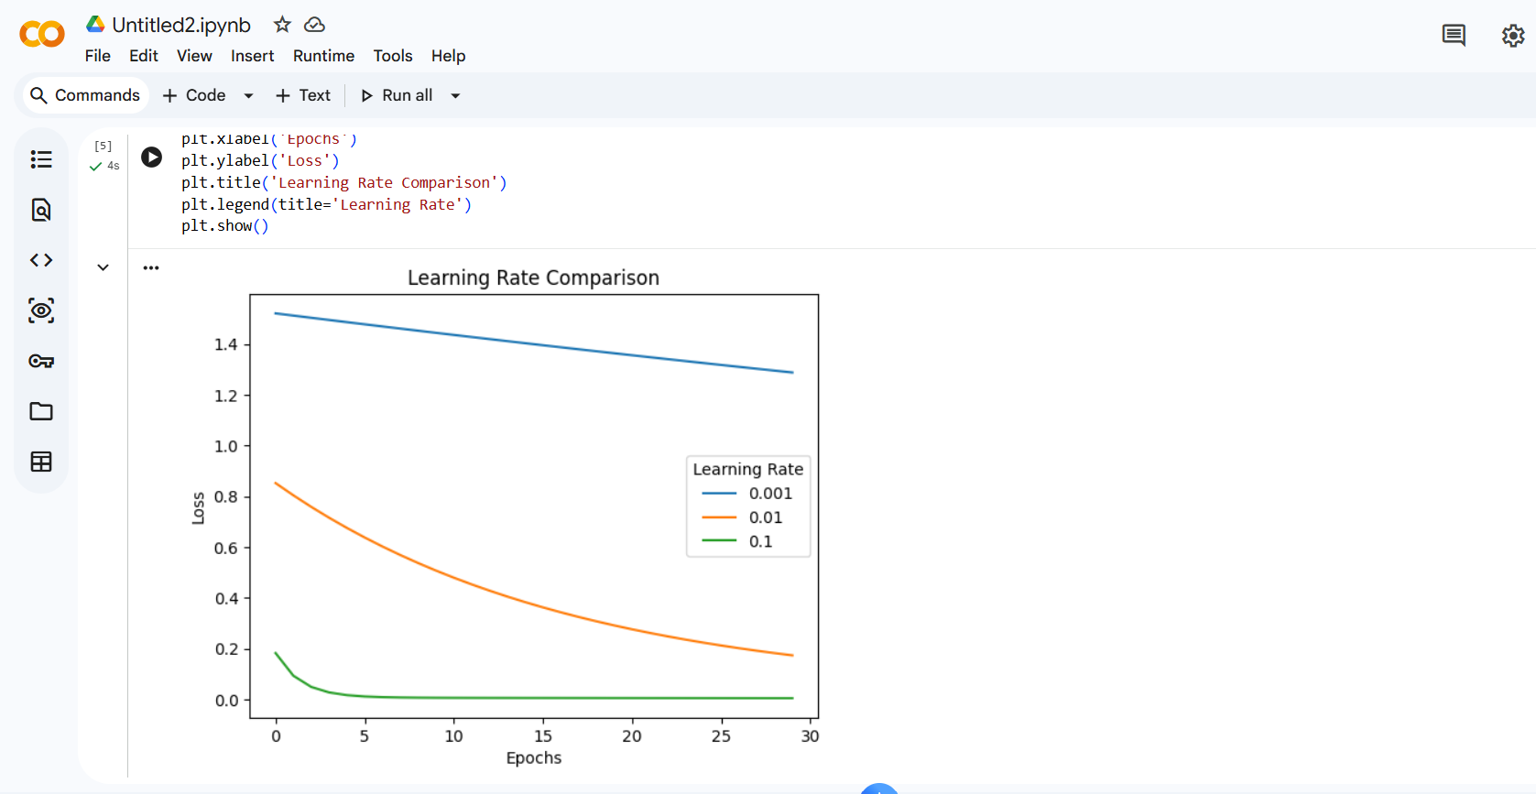

Result
Result: A small learning rate may converge slowly, while a large learning rate may cause fluctuations. A moderate learning rate often provides a good balance.

Question 3: Handwritten Digit Classification
An image-recognition system uses a neural network to classify handwritten digits. The model trained with SGD takes longer to reach a low training loss, whereas the model trained with Momentum converges more quickly. Analyze the performance differences between SGD and Momentum by training both models. under the same experimental conditions. Use NumPy to compare epoch-wise losses and Matplotlib to visualize convergence. Explain how Momentum influences updates when gradients consistently point in a similar direction.
Packages: NumPy, TensorFlow, Keras, Matplotlib
Aim: To compare SGD and Momentum using the MNIST dataset.

Program
import numpy as np
import tensorflow as tf
import matplotlib.pyplot as plt
(X, y), _ = tf.keras.datasets.mnist.load_data()
X = X[:5000].astype('float32') / 255
y = y[:5000]
# SGD model
m1 = tf.keras.Sequential([
tf.keras.layers.Input(shape=(28, 28)),
tf.keras.layers.Flatten(),
tf.keras.layers.Dense(32, activation='relu'),
tf.keras.layers.Dense(10, activation='softmax')
])
m1.compile(optimizer='sgd',
loss='sparse_categorical_crossentropy')
weights = m1.get_weights()
# Train SGD
h1 = m1.fit(X, y, epochs=5, batch_size=128, verbose=0)
# Momentum model
m2 = tf.keras.models.clone_model(m1)
m2.set_weights(weights)
m2.compile(
optimizer=tf.keras.optimizers.SGD(
learning_rate=0.01, momentum=0.9),
loss='sparse_categorical_crossentropy'
)
h2 = m2.fit(X, y, epochs=5, batch_size=128, verbose=0)
plt.plot(np.array(h1.history['loss']), label='SGD')
plt.plot(np.array(h2.history['loss']), label='Momentum')
plt.xlabel('Epochs')
plt.ylabel('Loss')
plt.legend()
plt.show()
Output:
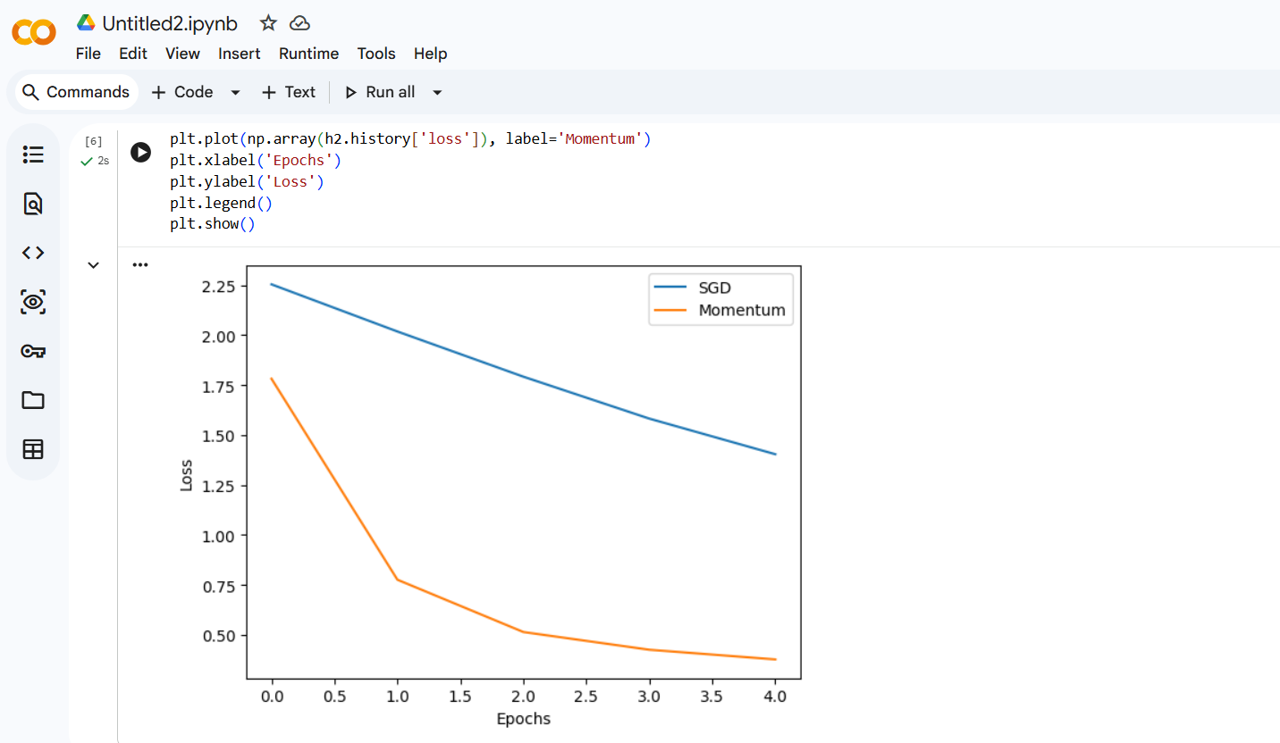

Result
Result: Momentum can accelerate convergence by using information from previous gradients.

Question 4: Disease Risk Classification

A healthcare analytics team builds a neural network to classify patient records into risk categories. The team observes that Adam reduces training loss quickly, while ordinary Gradient Descent requires more epochs to achieve a similar loss value. Analyze the convergence behavior of Gradient Descent and Adam by training comparable Keras models with TensorFlow. Record the loss values using NumPy and plot the results using Matplotlib. Evaluate the differences in convergence speed and training stability, and explain why Adam's adaptive learning rates may be beneficial. Packages: NumPy, TensorFlow, Keras, Matplotlib

Aim: To compare Gradient Descent and Adam for binary classification.

Program
import numpy as np
import tensorflow as tf
import matplotlib.pyplot as plt
np.random.seed(10)
X = np.random.rand(200, 4)
y = (X.sum(axis=1) > 2).astype(int)
# Gradient Descent
m1 = tf.keras.Sequential([
tf.keras.layers.Input(shape=(4,)),
tf.keras.layers.Dense(8, activation='relu'),
tf.keras.layers.Dense(1, activation='sigmoid')
])
m1.compile(optimizer=tf.keras.optimizers.SGD(0.01),
loss='binary_crossentropy')
h1 = m1.fit(X, y, epochs=20, verbose=0)
# Adam
m2 = tf.keras.Sequential([
tf.keras.layers.Input(shape=(4,)),
tf.keras.layers.Dense(8, activation='relu'),
tf.keras.layers.Dense(1, activation='sigmoid')
])
m2.compile(optimizer='adam', loss='binary_crossentropy')
h2 = m2.fit(X, y, epochs=20, verbose=0)
plt.plot(np.array(h1.history['loss']), label='Gradient Descent')
plt.plot(np.array(h2.history['loss']), label='Adam')
plt.xlabel('Epochs')
plt.ylabel('Loss')
plt.legend()
plt.show()
Output:
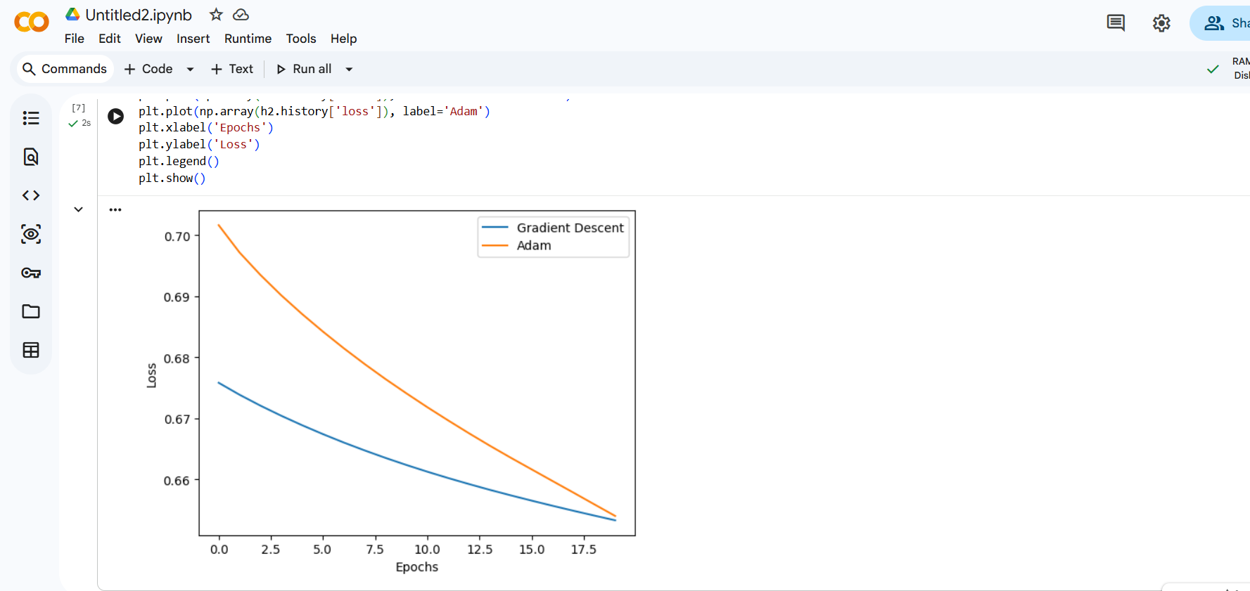

Result
Result: Adam often reduces loss faster because it adapts learning rates for individual parameters. This example uses synthetic data and is not suitable for real patient risk predictions.

Question 5: Optimizer Comparison for Sales Forecasting

A retail company develops a neural network to forecast weekly sales. Four versions of the model are trained using Gradient Descent, SGD, Momentum and Adam. The models show different training-loss patterns, convergence speeds and validation performance. Analyze and compare the four optimizers by training the models using TensorFlow and Keras under comparable conditions. Use NumPy to store and compare training and validation losses, and Matplotlib to plot the loss curves. Identify which optimizer provides the most suitable combination of convergence speed, stability and validation performance, and justify the selection using experimental evidence. Packages: NumPy, TensorFlow, Keras, Matplotlib

Aim: To compare Gradient Descent, SGD, Momentum, and Adam using validation loss.

Program
import numpy as np
import tensorflow as tf
import matplotlib.pyplot as plt
np.random.seed(10)
X = np.arange(1, 101).reshape(-1, 1) / 100
y = (50 + 20 * X[:, 0] +
np.random.normal(0, 2, 100)) / 100
X_train, X_val = X[:80], X[80:]
y_train, y_val = y[:80], y[80:]
optimizers = {
'Gradient Descent': tf.keras.optimizers.SGD(0.01),
'SGD': tf.keras.optimizers.SGD(0.01),
'Momentum': tf.keras.optimizers.SGD(0.01, momentum=0.9),
'Adam': tf.keras.optimizers.Adam(0.001)
}
for name, opt in optimizers.items():
model = tf.keras.Sequential([
tf.keras.layers.Input(shape=(1,)),
tf.keras.layers.Dense(8, activation='relu'),
tf.keras.layers.Dense(1)
])
model.compile(optimizer=opt, loss='mse')
batch = 80 if name == 'Gradient Descent' else 8
h = model.fit(
X_train, y_train,
epochs=20,
batch_size=batch,
validation_data=(X_val, y_val),
verbose=0
)
plt.plot(h.history['val_loss'], label=name)
plt.xlabel('Epochs')
plt.ylabel('Validation Loss')
plt.title('Optimizer Comparison')
plt.legend()
plt.show()
Output:
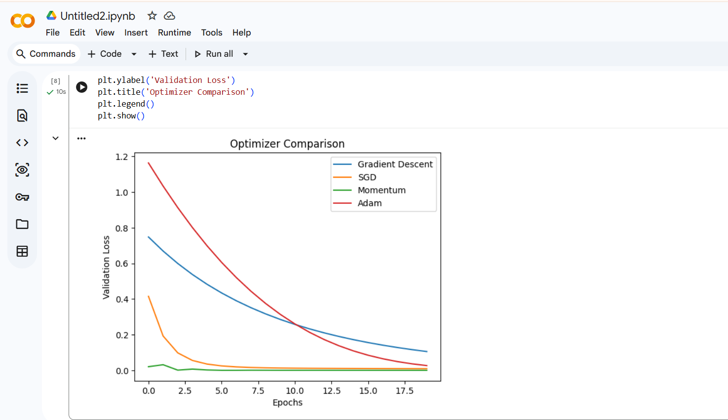

Result
Result: Validation loss curves help identify which optimizer performs best on unseen data. The actual results determine the best optimizer.

